Unit 3 Algorithmics
Submit Task – Week 6

Prim’s Algorithm
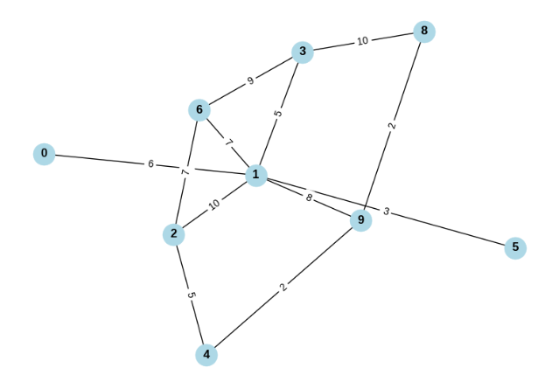
Run Prim’s Algorithm on the graph above. Start with vertex 1, and state the order in which you added edges to the tree. (Give each edge as the two vertices it connects). State also the weight of the tree.
Further Questions
- How can a priority queue be used in Prim’s algorithm to improve efficiency?
- Assuming all edge weights are positive, under what conditions will an edge with the smallest weight not appear in the resulting tree?
- Explain why Prim’s algorithm is ‘greedy’.
- Will Prim’s work with negative edges? Explain why/why not.

